**Phòng Giáo dục và Đào tạo ...**

**Đề thi Học kì 1 môn Tiếng Anh lớp 3**

**Năm học 2024 - 2025**

**Môn: Tiếng Anh lớp 3**

*Thời gian làm bài: 35 phút*

*(không kể thời gian phát đề)*

**(Đề số 1)**

**1. Listen and circle.**

1. a. We play badminton at school.

    b. I have a blue notebook.

2. a. This is my new pen.

    b. There are five pencils.

3. a. They are my books.

    b. Let’s go home!

4. a. Stand up, please!

    b. Can you speak louder, Mai?

**2. Listen and tick.**

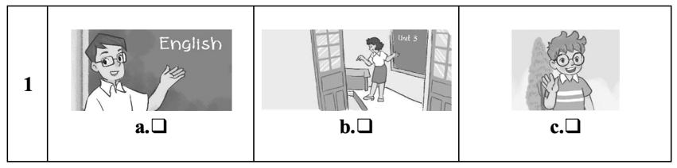

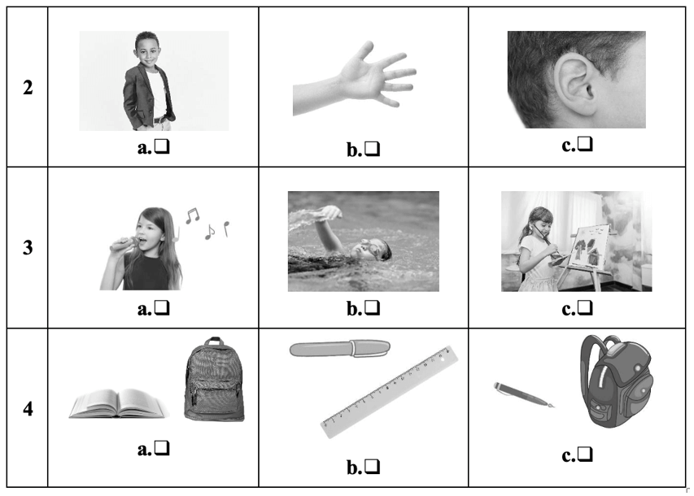

**3. Read and tick.**

1. A: Hi. I’m Nam.

    B: Hi, Nam. I’m Mary.

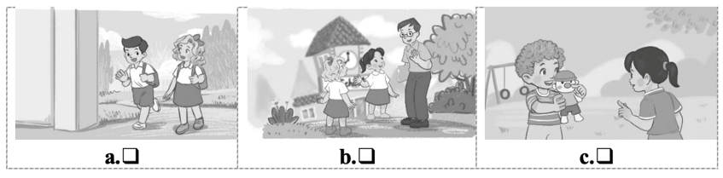

2. A: May I come in?

    B: Yes, you can.

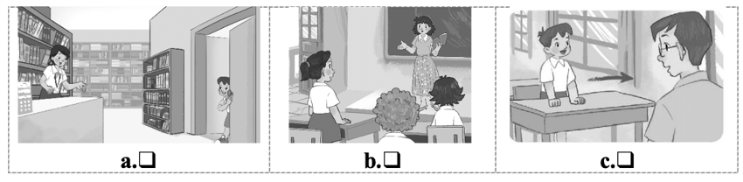

3. A: What colour are they?

    B: They are black and white.

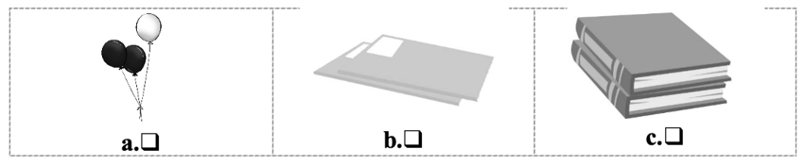

4. A: What do you do at break time?

    B: I play table tennis.

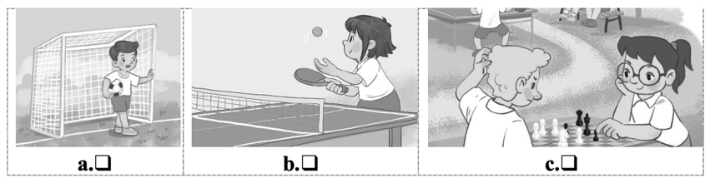

**4. Look and write.**

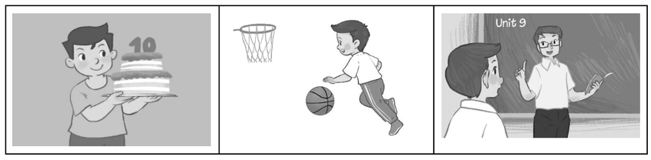

Hi! I (1) ________ Nam. I’m (2) ________I like playing (3) ________. At school, my favourite subject is (4) ________.

**5. Let’s talk.**

|  |  |  |  |  |
| --- | --- | --- | --- | --- |
| 1. Greeting/  Responding to greetings | 2. Asking the pupil’s name/ age | 3. Introducing someone | 4. Asking questions about parts of the body | 5. Asking about hobbies |
| 6. Making suggestions/ Expressing agreement | 7. Giving instructions/ Asking for permission | 8. Asking about school things | 9. Asking about the colours of school things | 10. Talking about break time activities |

**ANSWER KEY**

**1.**

Audio script:

1. We play badminton at school.

2. There are five pencils.

3. Let’s go home!

4. Stand up, please!

Key: 1. a   2. b   3. b   4. a

**2.**

Audio script:

1. A: Ben, is that ...?

    B: My teacher, Mum. Good morning, Mr Long.

2. A: What’s  this?

    B: A hand?

    A: No, it isn’t. It’s an ear.

3. A: What’s  your hobby?

    B: Well, I like swimming.

4. Look, Ben. I have a pen and a ruler.

 Key: 1. a     2. c    3. b     4. b

**3.**

 1. a    2. a    3. a     4. b

**4.**

 (1) am      (2) 10/ 10 years old    (3) basketball      (4) English

**5.**

Suggested questions and answers:

1. Hello, (pupil’s name). How are you? (Giving clues: Are you fine?/ OK? Yes? No?)

2. Hi! My name’s _____________. What’s  your name?/ How old are you?

(Giving clues: My name’s ____./ I’m _____ and you are _______./

Are you ______? Yes? No?)

3. Is this (one pupil’s name)?

4. What’s this?/ Touch your (a body part).

 (Point to any body parts learnt to ask or give commands to check pupil’s understanding.)

5. What’s  your hobby? (Giving clues: Do you like (swimming)? Swimming? Yes? No?)

6. Is this __________?

    Let’s ___________.

7. May ___________?

   (Point to one flash card, have the pupil give instructions or ask for permission.)

8. I have _______. Do you have _______?

9. What colour is it? What colour are they? (Giving clues: Is it red? Yes? No?)

10. I play badminton at break time. What about you, (pupil’s name)?

*For some topics, the teacher points to the flash card or realia, has the pupils listen and say/ respond. Depending on the pupil's speaking performance, the teacher can give him/ her some clues to encourage him/ her to speak English.*